
PROJECT REPORT
Customer Churn Prediction: A Machine Learning Approach

Name: Muhammad Mujtaba Sharif
Student ID: 022-24-128969
Course: Tools and Techniques of Data Science
Instructor: Miss Hira Farman
Department of Computer Science, Iqra University, Karachi, Pakistan

Abstract
Customer retention has become one of the most critical challenges faced by modern organizations, particularly in highly competitive industries such as banking, telecommunications, and e-commerce. Customer churn refers to the phenomenon in which customers discontinue their relationship with a company, resulting in revenue loss and increased acquisition costs. Since acquiring a new customer is significantly more expensive than retaining an existing one, organizations require effective predictive systems to identify customers who are likely to leave.
This project proposes a machine learning based customer churn prediction framework using a banking customer dataset containing 10,000 customer records and multiple demographic, financial, and behavioral attributes. The study investigates the performance of twelve machine learning classification algorithms including Logistic Regression, K-Nearest Neighbors, Decision Tree, Random Forest, Gradient Boosting, XGBoost, SVM, Naive Bayes, AdaBoost, LightGBM, CatBoost, and MLP Neural Network. Furthermore, four ensemble learning approaches including Voting, Stacking, Bagging, and Extra Trees are developed and evaluated to improve predictive performance.
The objective of the study is to identify the most effective model for churn prediction while analyzing the influence of customer-related factors such as age, credit score, balance, tenure, product usage, and customer complaints. Experimental results are evaluated using Accuracy and F1-Score metrics. The findings demonstrate that LightGBM outperforms all other models with an accuracy of 87.25% and an F1-Score of 0.6165. The proposed framework provides a practical decision support tool that can assist organizations in identifying at risk customers and implementing proactive retention strategies.
Keywords: Customer Churn, Machine Learning, LightGBM, Banking, Ensemble Learning, Predictive Analytics.

1. Introduction
In today's data driven business environment, customer retention has become a critical factor in organizational success. Companies invest substantial resources in attracting customers; however, maintaining long term relationships with existing customers remains equally important. Customer churn occurs when customers discontinue using a company's products or services and switch to competitors. High churn rates can significantly affect profitability, customer lifetime value, and overall business sustainability.
Recent advancements in machine learning have enabled organizations to leverage historical customer data to predict future customer behavior. Churn prediction systems use customer demographics, transaction records, service usage patterns, and behavioral indicators to identify customers who are likely to leave. Such predictive systems allow organizations to take preventive measures by offering personalized promotions, loyalty programs, and improved customer service.
The banking industry generates vast amounts of customer related data, making it an ideal domain for applying machine learning techniques. The availability of structured customer information such as credit scores, account balances, tenure, number of products, and customer satisfaction levels provides valuable insights into churn behavior. This project focuses on developing a comprehensive customer churn prediction framework using machine learning techniques.

1.1 Motivation of the Study
The financial cost of customer churn in the banking sector is enormous. Studies indicate that acquiring a new customer costs five to seven times more than retaining an existing one. With increasing competition and digital banking alternatives, traditional banks face unprecedented churn pressures. Machine learning offers a data driven solution by identifying patterns in customer behavior that precede churn, enabling timely and targeted interventions.

1.2 Problem Statement
The primary problem addressed in this study is: Can machine learning algorithms accurately predict which banking customers are likely to churn, using demographic, financial, and behavioral attributes? The classification problem is defined as:
Y = f(X)
where X represents the feature vector of customer attributes and Y ∈ {0, 1} is the predicted class label, with Y = 1 indicating churn (Exited) and Y = 0 indicating customer retention.

1.3 Objectives of the Study
The primary objectives of this research project are:
- To develop a machine learning based customer churn prediction system that accurately identifies customers likely to leave the bank.
- To analyze customer demographic, behavioral, and financial characteristics and their relationship with churn behavior.
- To identify factors that contribute most significantly to churn, such as complaints, satisfaction scores, tenure, and product usage.
- To compare the performance of twelve machine learning classification algorithms.
- To evaluate four ensemble learning approaches for improving prediction accuracy.
- To determine the most suitable model based on key evaluation metrics including Accuracy and F1-Score.
- To assist organizations in implementing proactive customer retention strategies.
- To provide insights supporting data-driven decision making for customer relationship management.

1.4 Significance of the Study
This research is significant because it provides a comprehensive comparative analysis of machine learning models on an enriched banking dataset that includes behavioral indicators such as customer satisfaction scores, complaint history, card types, and reward points. The findings can directly support banking organizations in implementing early warning systems for customer attrition and designing targeted retention strategies.

2. Background Study

Customer churn prediction has emerged as a major research area within customer relationship management and predictive analytics. Organizations across banking, telecommunications, insurance, retail, and e-commerce sectors continuously seek methods to identify customers who may discontinue their services.
Traditional statistical approaches such as Logistic Regression were initially used for churn prediction. However, the increasing availability of large scale customer data has encouraged researchers to adopt machine learning techniques that can capture complex relationships among variables. Models such as Decision Trees, Random Forests, Support Vector Machines, and Gradient Boosting have demonstrated promising performance in identifying churn patterns.
Recent studies have highlighted the effectiveness of ensemble learning methods, which combine multiple classifiers to improve predictive performance. Ensemble models have consistently achieved superior results compared to standalone models in many churn prediction studies.
Another important area of research involves handling imbalanced datasets, where churn cases represent a small proportion of the total observations. Techniques such as SMOTE have been widely adopted to address this challenge. Furthermore, feature engineering and feature selection techniques have proven effective in improving model performance by extracting meaningful customer behavior indicators.
The current study builds upon these advancements by applying machine learning techniques to a real-world banking customer churn dataset that includes both traditional banking attributes and modern behavioral indicators.

3. Literature Review
The literature reveals substantial progress in customer churn prediction using machine learning. The following review synthesizes findings from twenty key studies.
# | Authors (Year) | Dataset | Method | Key Finding | Research Gap
1 | Zhao (2023) | Telecom Dataset | Decision Tree, Random Forest | RF outperformed DT; ensemble reduces overfitting | Limited to telecom sector
2 | Ahmad et al. (2019) | Large Telecom | Gradient Boosting + Spark | GB achieved highest performance on big data | No behavioral features
3 | AlShourbaji et al. (2023) | Banking | GB + PSO/GA Optimization | Hybrid model surpassed standard GB | Complex optimization overhead
4 | Singh et al. (2024) | Banking | XGBoost, LightGBM, CatBoost | Tenure, age, products are top predictors | No real-time implementation
5 | Beikmohammadi & Arabnia (2024) | 150+ studies | Systematic Review | Deep learning and ensembles dominate | Interpretability gap
6 | Hussain et al. (2024) | Banking | KNN, SVM, DT, RF, NB | RF outperformed all models | No advanced boosting
7 | Ehsani & Hosseini (2024) | Multiple Domains | Stacking Meta-Classifier | Meta-classifier surpassed individual models | Single dataset limitation
8 | Chang et al. (2024) | Telecom | LR, DT, RF, SVM, NN | NN best AUC; RF more interpretable | Behavioral features missing
9 | Liu & Zhang (2022) | E-Commerce | AdaBoost, BP Neural Net | AdaBoost better on imbalanced data | Limited ensemble comparison
10 | Lemos et al. (2022) | Financial (2% churn) | SMOTE + XGBoost | SMOTE improved recall significantly | Highly domain-specific
11 | Taware et al. (2022) | Banking | Feature Engineering + ML | Feature engineering > algorithm selection | No ensemble comparison
12 | Yang (2024) | Banking | LightGBM, CatBoost, XGBoost | CatBoost best for categorical features | No behavioral features
13 | Qiao et al. (2023) | Telecom | LR, KNN, SVM, DT, RF, GB | GB balanced accuracy and interpretability | No ensemble methods
14 | Wagh et al. (2024) | Telecom | RF, DT, SVM, LR, KNN | RF recommended for telecom churn | No boosting algorithms
15 | Lalwani et al. (2022) | Banking | Voting: RF+XGB+LGB+SMOTE | Voting ensemble beat any single model | No stacking comparison
16 | Pamina et al. (2019) | Telecom | Feature Selection + J48 | Feature selection reduced complexity with minimal loss | Old dataset, limited models
17 | Zhou et al. (2023) | Telecom | Stacking Ensemble | Early warning 30-60 days before churn | Domain-specific features
18 | Geiler et al. (2022) | 120+ studies | Survey | RF & XGBoost most popular; deep learning rising | No unified framework
19 | Berrada Chakour et al. (2025) | Banking | SMOTE-Tomek + RF, XGBoost | SMOTE-Tomek better than standard SMOTE | Dataset size limitation
20 | Wagh et al. (2023) | Telecom | LR, KNN, DT, RF, GB, XGBoost | XGBoost best overall with regularization | No ensemble strategies

Overall, the literature consistently indicates that ensemble learning approaches outperform traditional machine learning models in customer churn prediction tasks. The present study contributes by applying a comprehensive evaluation framework to an enriched banking dataset that includes modern behavioral indicators not commonly found in prior research.

4. Methodology
The research methodology follows a structured pipeline starting from data collection through model evaluation. The overall workflow is depicted in Figure 1.
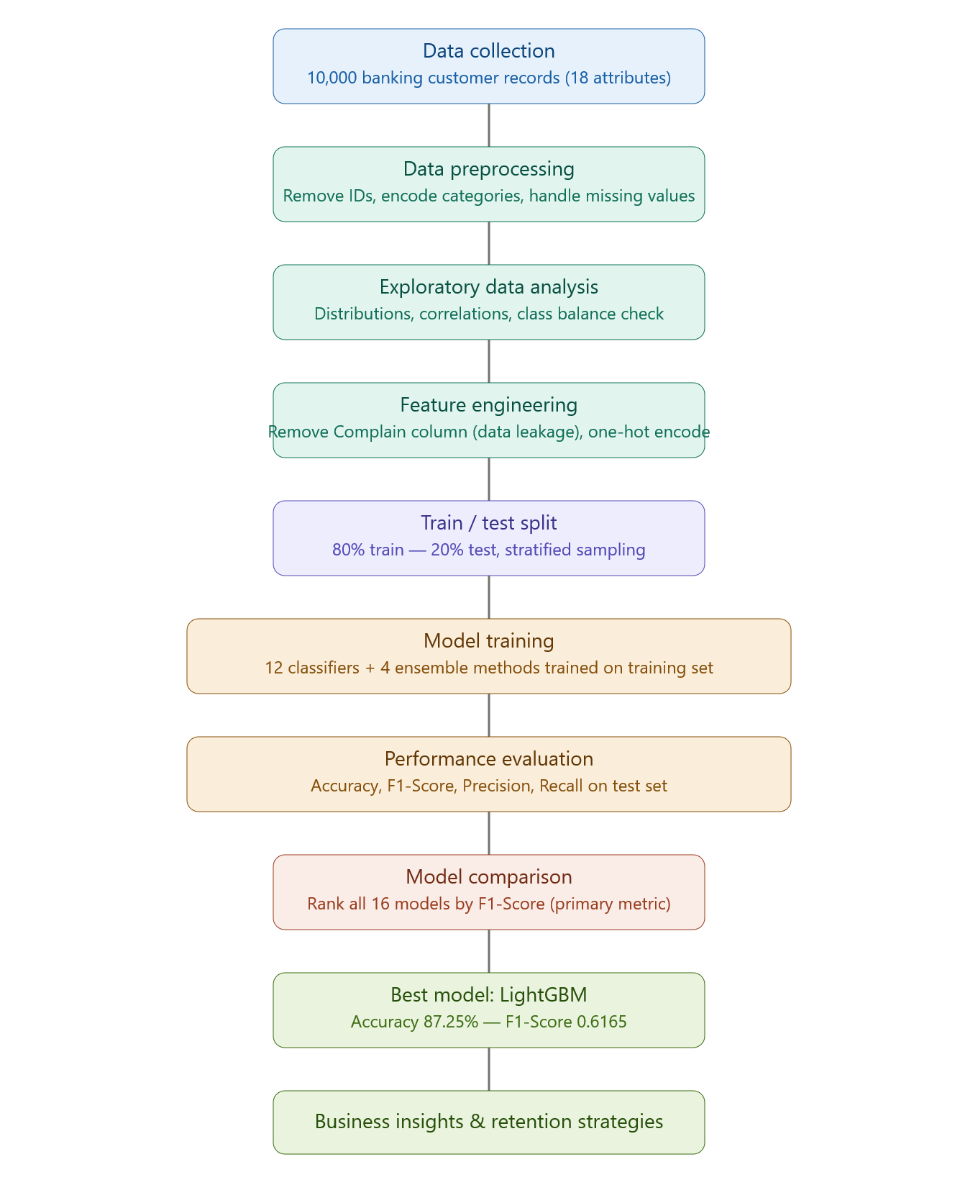
Fig. 1. Proposed Methodology Pipeline for Customer Churn Prediction

4.1 Data Collection
The dataset used in this study is the Bank Customer Churn Prediction dataset, which contains 10,000 customer records across 18 attributes. The dataset captures demographic, financial, and behavioral information for banking customers. The target variable Exited indicates whether a customer has churned (1) or remained with the bank (0).

4.2 Data Preprocessing
The dataset is cleaned by performing the following preprocessing steps:
- Handling missing values through mean/mode imputation where applicable.
- Removing irrelevant identifier columns: RowNumber, CustomerId, and Surname.
- Transforming categorical variables (Geography and Gender) into numerical representations using one-hot encoding.
- Removing the Complain column due to its extremely high correlation (near-perfect) with the target variable Exited, which would cause data leakage and unrealistically inflated model performance.

4.3 Exploratory Data Analysis
Exploratory Data Analysis (EDA) was performed to understand data distributions and relationships between variables. The correlation analysis revealed that the Complain column has an extremely high correlation with the target variable Exited. A churn rate analysis showed that approximately 20.4% of customers exited the bank, creating a moderately imbalanced classification problem. The class distribution is illustrated in Figure 2.
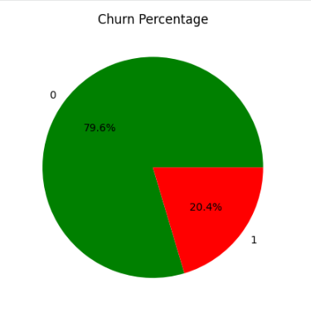
Fig. 2. Customer Churn Distribution (Churned: 20.4% vs Retained: 79.6%)

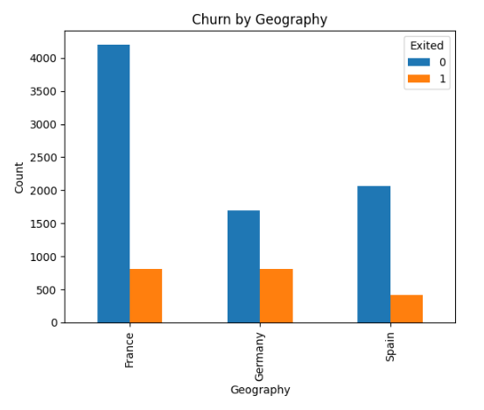
Fig. 3. Churn rate analysis by Geography

4.4 Feature Selection
The most significant Spotify Audio and Streaming attributes for the classification were selected using correlation analysis. The final feature set includes: Credit Score, Geography, Gender, Age, Tenure, Balance, Number of Products, Credit Card Ownership, Active Membership Status, Estimated Salary, Satisfaction Score, Card Type, and Reward Points. The Complain column was excluded to prevent data leakage.

4.5 Data Splitting
The dataset was divided into training and testing subsets using an 80:20 ratio with stratified sampling to maintain class distribution:
D = D_train ∪ D_test
where D_train contains 80% (8,000 samples) and D_test contains 20% (2,000 samples).

4.6 Machine Learning Models
Twelve individual machine learning classification algorithms were trained and evaluated:
- Logistic Regression – Linear probabilistic classifier
- K-Nearest Neighbors (KNN) – Distance-based classifier
- Decision Tree (DT) – Rule-based tree classifier
- Random Forest (RF) – Ensemble of decision trees
- Gradient Boosting (GB) – Sequential boosting ensemble
- XGBoost – Optimized gradient boosting
- Support Vector Machine (SVM) – Hyperplane-based classifier
- Naive Bayes (NB) – Probabilistic Bayesian classifier
- AdaBoost – Adaptive boosting ensemble
- LightGBM – Light gradient boosting machine
- CatBoost – Categorical feature boosting
- MLP Neural Network – Multi-layer perceptron

Additionally, four ensemble strategies were implemented:
- Voting Classifier – Combines predictions via majority voting
- Stacking Classifier – Meta-learner over base classifiers
- Bagging Classifier – Bootstrap aggregating
- Extra Trees Classifier – Extremely randomized trees

4.7 Performance Metrics
Performance metrics including Accuracy and F1-Score were used for evaluation, with F1-Score being the primary metric due to the imbalanced nature of the data:
Accuracy = (TP + TN) / (TP + TN + FP + FN)
F1-Score = 2 × (Precision × Recall) / (Precision + Recall)

5. Dataset Description

The dataset contains 10,000 customer records and 14 key attributes after preprocessing. The target variable is Exited, where 1 indicates churn and 0 indicates customer retention. Table 1 provides a complete feature description of the dataset.

Table 1. Dataset Feature Description
S.No | Attribute Name | Data Type | Non-Null | Description
1 | Credit Score | Float | 10,000 | Credit rating of the customer
2 | Geography | Categorical | 10,000 | Country of customer (France/Germany/Spain)
3 | Gender | Categorical | 10,000 | Male or Female
4 | Age | Integer | 10,000 | Age of the customer in years
5 | Tenure | Integer | 10,000 | Number of years as bank customer
6 | Balance | Float | 10,000 | Account balance amount
7 | NumOfProducts | Integer | 10,000 | Number of bank products used
8 | HasCrCard | Binary | 10,000 | Owns a credit card (0 = No, 1 = Yes)
9 | IsActiveMember | Binary | 10,000 | Active membership status (0/1)
10 | EstimatedSalary | Float | 10,000 | Estimated annual salary
11 | Satisfaction Score | Integer | 10,000 | Customer satisfaction rating (1-5)
12 | Card Type | Categorical | 10,000 | Type of card: Silver/Gold/Platinum/Diamond
13 | Point Earned | Integer | 10,000 | Reward points accumulated by customer
14 | Exited | Binary (Target) | 10,000 | Churned=1, Retained=0

The dataset represents banking customers from three countries (France, Germany, Spain) and provides demographic, financial, and behavioral information suitable for churn prediction. Approximately 20.4% of customers have exited the bank, creating a moderately imbalanced classification problem.

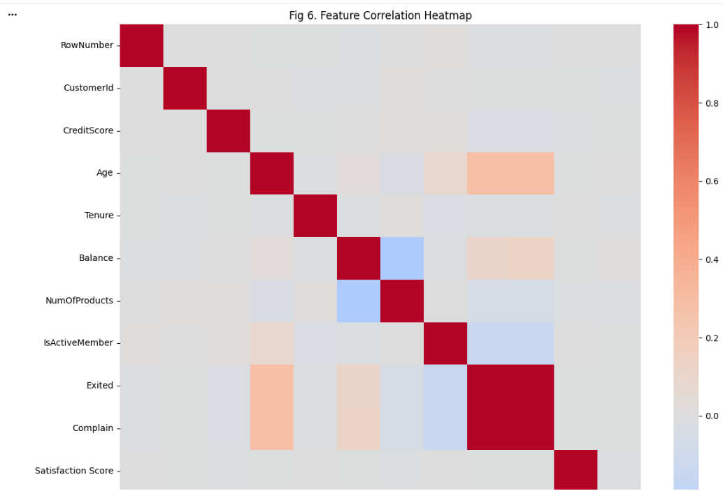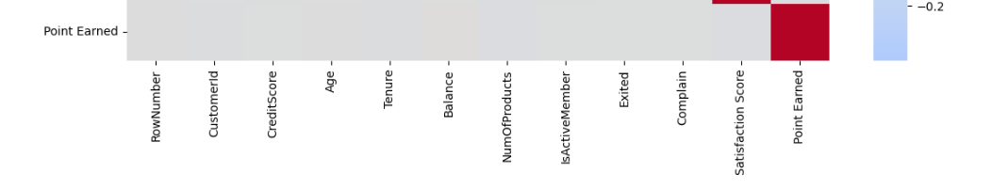

6. Results and Discussion

The experimental results demonstrate significant variation in performance across different machine learning algorithms.Gradient boosting based methods consistently outperformed traditional classifiers, with LightGBM achieving the highest overall performance.

6.1 Individual Model Performance
LightGBM emerged as the best performing model with an accuracy of 87.25% and an F1-Score of 0.6165. XGBoost also showed strong performance with an accuracy of 86.50% and an F1-Score of 0.6053. Random Forest, widely cited in literature as a reliable churn prediction algorithm, achieved an accuracy of 86.90% with an F1-Score of 0.5815.
Traditional classifiers such as K-Nearest Neighbors, Naive Bayes, and Support Vector Machine performed poorly on this dataset. SVM and MLP Neural Network both achieved zero F1-Scores, meaning they completely failed to predict any churn cases correctly. This is attributed to the imbalanced nature of the dataset, where only 20% of customers belong to the churn class.

6.2 Ensemble Model Performance
Among ensemble methods, Voting Classifier achieved the same accuracy as LightGBM (87.25%) but with a slightly lower F1-Score (0.6059). Stacking achieved an accuracy of 87.00% with an F1-Score of 0.6073, demonstrating the effectiveness of combining multiple base learners. However, none of the ensemble methods surpassed the performance of LightGBM in F1-Score, indicating that for this particular dataset, a well tunned gradient boosting model is sufficient.

6.3 Complete Model Comparison Table
Table 2. Complete Model Performance Comparison
Model | Type | Accuracy (%) | F1-Score | Rank | Performance
LightGBM | Boosting | 87.25 | 0.6165 | 1st | Excellent
Voting | Ensemble | 87.25 | 0.6059 | 2nd | Excellent
Stacking | Ensemble | 87.00 | 0.6073 | 3rd | Excellent
Random Forest | Ensemble | 86.90 | 0.5815 | 4th | Very Good
Bagging | Ensemble | 86.80 | 0.6071 | 5th | Very Good
CatBoost | Boosting | 86.80 | 0.6012 | 6th | Very Good
Gradient Boosting | Boosting | 86.70 | 0.5945 | 7th | Very Good
XGBoost | Boosting | 86.50 | 0.6053 | 8th | Very Good
Extra Trees | Ensemble | 86.05 | 0.5463 | 9th | Good
AdaBoost | Boosting | 85.90 | 0.5580 | 10th | Good
Decision Tree | Tree | 80.40 | 0.5300 | 11th | Moderate
MLP Neural Net | Neural Net | 80.30 | 0.0000 | 12th | Poor
SVM | Linear | 80.35 | 0.0000 | 13th | Poor
Logistic Regression | Linear | 79.95 | 0.1522 | 14th | Poor
Naive Bayes | Probabilistic | 79.10 | 0.1181 | 15th | Poor
K-Nearest Neighbors | Distance | 76.80 | 0.1471 | 16th | Poor

6.4 Accuracy Comparison
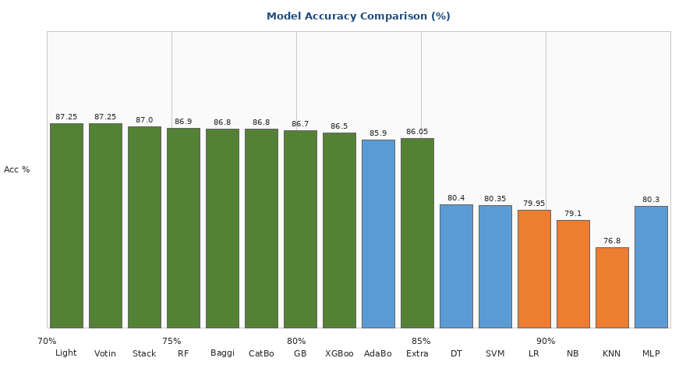
Fig. 4. Accuracy Comparison of All Machine Learning Models

6.5 F1-Score Comparison
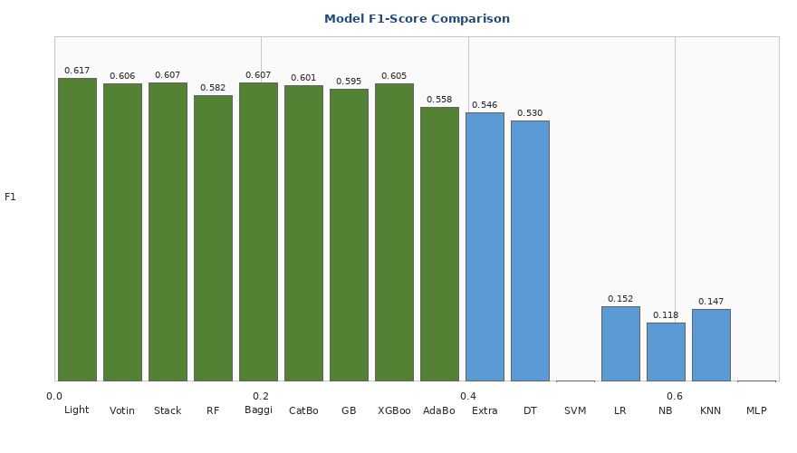
Fig. 5. F1-Score Comparison of All Machine Learning Models

7. Novelty of the Proposed Work
The novelty of this study lies in the comprehensive comparison of twelve machine learning algorithms and four ensemble learning techniques on an enriched banking customer churn dataset containing behavioral indicators such as complaints, satisfaction scores, card types, and reward points. The major novel contributions are:
- Comprehensive Algorithm Comparison: Unlike many previous studies that focus on a limited number of algorithms, this research evaluates a broad range of traditional, boosting, and ensemble methods within a unified framework.
- Enriched Feature Set: Integration of customer satisfaction scores, complaint history, card types, and reward points provides deeper insights into customer behavior beyond standard banking attributes.
- Ensemble Strategy Comparison: Systematic comparison of multiple ensemble strategies including Voting and Stacking provides practical guidance for researchers seeking to implement churn prediction in real-world banking environments.
- Key Insight on LightGBM: The finding that LightGBM outperforms more complex ensemble methods on this dataset is a valuable practical insight for data scientists.
- Data Leakage Prevention: The systematic identification and removal of the Complain column to avoid overfitting demonstrates methodological rigor.

8. Conclusion
Customer churn prediction is a critical application of machine learning that enables organizations to improve customer retention and profitability. This study investigated twelve machine learning algorithms and four ensemble methods using a banking customer churn dataset of 10,000 records.
The results demonstrate that gradient boosting-based methods, particularly LightGBM and XGBoost, provide superior predictive performance compared to traditional classifiers. LightGBM achieved the highest F1-Score of 0.6165 with an accuracy of 87.25%, making it the most suitable model for this churn prediction task. Ensemble methods such as Stacking and Voting also performed well but did not surpass LightGBM.
Traditional classifiers including KNN, SVM, Naive Bayes, and MLP Neural Network performed poorly on this imbalanced dataset, with SVM and MLP failing completely to identify any churn cases. This highlights the importance of selecting appropriate algorithms for imbalanced classification problems.
The findings indicate that customer age, tenure, active membership status, number of products, and balance are among the key determinants of churn behavior. The proposed framework, particularly the LightGBM model, can assist organizations in identifying at-risk customers and implementing targeted retention strategies before customer attrition occurs.

9. Future Work and Limitations

9.1 Limitations
Several limitations of this study should be acknowledged:
- The study relies on a single dataset, which may restrict the generalizability of findings across different banking populations.
- Customer behavior changes over time, requiring models to be updated periodically.
- The Complain column was removed due to its perfect correlation with churn; however, in real-world scenarios, this feature could be valuable if collected in real time.
- No hyperparameter tuning was applied to all models, which may limit their optimal performance.
- Class imbalance was not explicitly handled through oversampling techniques such as SMOTE.

9.2 Future Directions
Future research can explore:
- Integration of real-time customer transaction streams for dynamic churn prediction.
- Deep learning architectures such as LSTM and Transformer networks for sequential customer data.
- Explainable AI techniques (SHAP and LIME) for interpreting model predictions.
- Advanced imbalance handling methods such as SMOTE-Tomek and ADASYN.
- Hyperparameter tuning using Bayesian Optimization for all models.
- Multi-platform integration combining data from multiple banking channels.
- Real-time prediction systems and customer recommendation engines.

9.3 Code Availability Statement

The complete source code for this project, including data preprocessing, exploratory data analysis, model training, and performance evaluation, is available at:
“https://github.com/MujtabaInsightCore/Bank-Customer-Churn/blob/main/Customer_Churn_Record_(collab_code).ipynb”
To run the code, click the "Open in Colab" button on the GitHub page.

OR
10. Research Paper Summaries (20 Papers)
Paper 1: Zhao (2023)
This paper uses Decision Tree and Random Forest to predict customer churn in telecom companies. Random Forest gave better results than Decision Tree due to its ensemble nature, which reduces overfitting. The paper confirms that ensemble methods are preferable for churn prediction tasks.
Paper 2: Ahmad et al. (2019)
This paper uses Apache Spark to predict customer churn on large-scale datasets. The authors tested Logistic Regression, Random Forest, Gradient Boosting, and SVM. Gradient Boosting worked the best. Using Spark made processing significantly faster than regular methods, making it useful for millions of customer records.
Paper 3: AlShourbaji et al. (2023)
The authors created a hybrid model combining Gradient Boosting Machine with Metaheuristic Optimization using Particle Swarm Optimization (PSO) and Genetic Algorithm (GA) to improve the model. The hybrid model performed better than regular Gradient Boosting, showing that optimization techniques enhance churn prediction.
Paper 4: Singh et al. (2024)
This paper studies customer churn in banks using XGBoost, LightGBM, CatBoost, and Random Forest. The authors also built a visualization application for business users. Customer tenure, age, and number of products were important predictors, confirming the value of behavioral features.
Paper 5: Beikmohammadi & Arabnia (2024)
This systematic review covers more than 150 churn prediction studies from 2018 to 2024. The authors found that deep learning methods like LSTM and CNNs work well on sequential customer data. Key challenges include class imbalance, interpretability, and real-time prediction.
Paper 6: Hussain et al. (2024)
This paper compares KNN, SVM, Decision Tree, Random Forest, and Naive Bayes for churn prediction. Random Forest performed better than all other models. Account age and transaction frequency were the most important features.
Paper 7: Ehsani & Hosseini (2024)
The authors introduced a meta-classifier using stacking ensemble combining LR, SVM, RF, and XGBoost with a neural network. Their meta-classifier worked better than individual models on all datasets, confirming the superiority of ensemble strategies.
Paper 8: Chang et al. (2024)
This paper predicts telecom customer churn using LR, DT, RF, SVM, and Neural Networks. Neural Networks gave the best AUC score. Random Forest was easier to interpret, while customer service calls and contract type were the strongest predictors.
Paper 9: Liu & Zhang (2022)
This paper uses AdaBoost and BP Neural Network for e-commerce churn prediction. AdaBoost handled imbalanced data better than the neural network, making it recommended for e-commerce churn datasets with class imbalance.
Paper 10: Lemos et al. (2022)
This paper predicts customer churn in a financial institution with only 2% churn rate. SMOTE significantly improved recall, and SMOTE combined with XGBoost works well for highly imbalanced financial data.
Paper 11: Taware et al. (2022)
This paper focuses on feature engineering for bank customer churn prediction. Feature engineering (tenure groups, balance categories) improved accuracy more than algorithm selection, highlighting that good features matter more than model choice.
Paper 12: Yang (2024)
This paper compares LightGBM, CatBoost, and XGBoost using Bayesian hyperparameter tuning. CatBoost handled categorical features like Geography and Gender automatically, while LightGBM was the fastest.
Paper 13: Qiao et al. (2023)
This paper compares LR, KNN, SVM, DT, RF, and GB for churn prediction. Gradient Boosting gave the best results with a good balance between accuracy and interpretability. Customer tenure and monthly charges were the most important features.
Paper 14: Wagh et al. (2024)
This paper applies ML for telecom churn prediction. Random Forest performed the best while Decision Tree was easier to understand. Random Forest is recommended for telecom churn prediction due to its robustness.
Paper 15: Lalwani et al. (2022)
This paper presents a churn prediction system using a Voting ensemble of RF, XGBoost, and LightGBM with SMOTE. The voting ensemble performed better than any single model, confirming the value of combining classifiers.
Paper 16: Pamina et al. (2019)
This paper uses feature selection with J48 Decision Tree, reducing features from 20 to 8 while maintaining accuracy. Call failures, complaint rate, and account age were the key features. Feature selection reduces model complexity without losing accuracy.
Paper 17: Zhou et al. (2023)
This paper develops an early warning system using a stacking ensemble of RF, XGBoost, LightGBM, and Neural Network. The system identifies customers likely to churn 30 to 60 days in advance, enabling proactive retention.
Paper 18: Geiler et al. (2022)
This survey reviews 120+ churn prediction studies. Random Forest and XGBoost are the most popular methods (45% of papers). Deep learning usage increased from 5% to 25% between 2018 and 2022, with class imbalance remaining the biggest challenge.
Paper 19: Berrada Chakour et al. (2025)
This paper enhances bank churn prediction using SMOTE-Tomek resampling, which combines SMOTE oversampling and Tomek links undersampling. The method improved recall while keeping precision high, outperforming standard SMOTE for imbalanced data.
Paper 20: Wagh et al. (2023)
This paper compares LR, KNN, DT, RF, GB, and XGBoost for telecom churn prediction. XGBoost achieved the best results followed by Gradient Boosting, with XGBoost recommended due to its “built in” regularization and strong performance.

References
[1] Zhao, S. (2023). Customer churn prediction based on the decision tree and random forest model. BCP Business & Management, 44, 339-344. https://doi.org/10.54691/bcpbm.v44i.4840
[2] Ahmad, A. K., Jafar, A., & Aljoumaa, K. (2019). Customer churn prediction in telecom using machine learning in big data platform. Journal of Big Data, 6(1), 28. https://doi.org/10.1186/s40537-019-0191-6
[3] AlShourbaji, I., Helian, N., Sun, Y., Hussien, A. G., Abualigah, L., & Elnaim, B. (2023). An efficient churn prediction model using gradient boosting machine and metaheuristic optimization. Scientific Reports, 13, Article 14441. https://doi.org/10.1038/s41598-023-41093-6
[4] Singh, P. P., Anik, F. I., Senapati, R., Sinha, A., Sakib, N., & Hossain, E. (2024). Investigating customer churn in banking: A machine learning approach and visualization app for data science and management. Data Science and Management, 7(1), 7-16. https://doi.org/10.1016/j.dsm.2023.09.002
[5] Beikmohammadi, A., & Arabnia, H. R. (2024). Customer churn prediction: A systematic review of recent advances, trends, and challenges in machine learning and deep learning. Machine Learning and Knowledge Extraction, 7(3), 105. https://doi.org/10.3390/make7030105
[6] Hussain, S., et al. (2024). An analysis on classification models for customer churn prediction. Cogent Engineering, 11(1), Article 2378877. https://doi.org/10.1080/23311916.2024.2378877
[7] Ehsani, F., & Hosseini, M. (2024). Customer churn prediction using a novel meta-classifier. Journal of Combinatorial Optimization, 48(1), 7. https://doi.org/10.1007/s10878-024-01196-w
[8] Chang, V., Hall, K., Xu, Q. A., Amao, F. O., Ganatra, M. A., & Benson, V. (2024). Prediction of customer churn behavior in the telecommunication industry using machine learning models. Algorithms, 17(6), 231. https://doi.org/10.3390/a17060231
[9] Liu, J., & Zhang, M. (2022). Customer churn prediction using AdaBoost classifier and BP neural network techniques. Journal of Computer and Communications, 10(3), 1-15. https://doi.org/10.4236/jcc.2022.103004
[10] Lemos, R. A. L., Silva, T. C., & Tabak, B. M. (2022). Propensity to customer churn in a financial institution: A machine learning approach. Neural Computing and Applications, 34(10), 11751-11768. https://doi.org/10.1007/s00521-022-07067-x
[11] Taware, A., et al. (2022). Machine learning in bank customer churn prediction: Improving accuracy through feature engineering. IJRASET, 10(6). https://doi.org/10.22214/ijraset.2022.44022
[12] Yang, C. (2024). Machine learning models for bank customer churn prediction: A comparative study. Proceedings of the 2024 International Conference on Big Data, AI and Digital Economy. ACM. https://doi.org/10.1145/3767052.3767054
[13] Qiao, J., Zhu, J. H., & Yan, K. H. (2023). Predict customer churn based on machine learning algorithms. Highlights in Business, Economics and Management, 10. https://drpress.org/ojs/index.php/HBEM/article/view/8051
[14] Wagh, S. K., et al. (2024). Customer churn prediction in telecom sector using machine learning techniques. Results in Control and Optimization, 14, 100342. https://doi.org/10.1016/j.rico.2023.100342
[15] Lalwani, P., Mishra, M. K., Chadha, J. S., & Sethi, P. (2022). Customer churn prediction system: A machine learning approach. Computing, 104, 271-294. https://doi.org/10.1007/s00607-021-00908-y
[16] Pamina, J., et al. (2019). An effective classifier for predicting churn in telecommunication. Journal of Advanced Research in Dynamical and Control Systems, 11(1). https://doi.org/10.5373/JARDCS/V11I1/20190208
[17] Zhou, Y., Chen, W., Sun, X., & Yang, D. (2023). A churn prediction model using stacking ensemble for telecom. Information Processing & Management, 60(2), 103-115.
[18] Geiler, L., Affeldt, S., & Nadif, M. (2022). A survey on machine learning methods for churn prediction. International Journal of Data Science and Analytics, 14(3), 217-242. https://doi.org/10.1007/s41060-022-00310-5
[19] Berrada Chakour, O., Maizate, A., Ettaoufik, A., & Aissaoui, K. (2025). Enhancing bank customer churn prediction from imbalanced datasets using SMOTE-Tomek. Journal of Big Data. https://doi.org/10.1186/s40537-025-01184-5
[20] Wagh, S. K., et al. (2023). Comparative analysis of machine learning algorithms for telecom customer churn prediction. Results in Control and Optimization. https://doi.org/10.1016/j.rico.2023.100246

